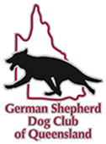
MINOR RAFFLE DRAW
Drawn 4/7/21

4 Prizes to be won.

$2 per ticket

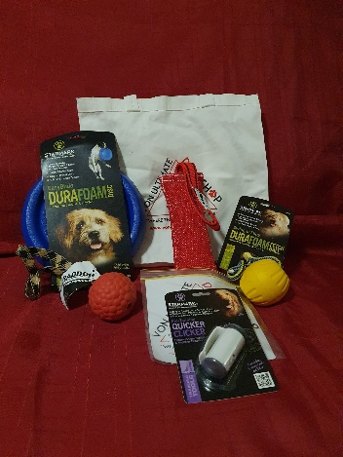
1st Prize
Sponsored by Von Ultimate Dog Shop
1 x Von Ultimate Dog Shop Tote bag
1 x Starmark Swing ‘n Fling DuraFoam Fetch Ball
1 x Starmark 9 Inch Easy Glide DuraFoam Disc
Total Value $165.00
1 x Starmark Pro-Training Quicker Clicker
1 x HST Ringo One Handle Tug
1 x Raddog Ringo Ball with Loop
1 x Von Ultimate Dog Shop Sticker
1 x Von Ultimate Dog Shop key ring

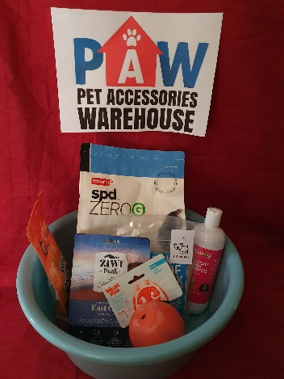
2nd Prize
Sponsored by Pet Accessories Warehouse
1 x Prime 100 Spd Zero 2.2kg Dog Food
1 x Ziwi Peak 140g Dog Food
Total Value $129.00
1 x Wagalot Meaty Loaf Mix
1 x 100g Loyalty Pet Treats
1 x Petway Everyday Pink shampoo
1 x Westpaw Dog Toy

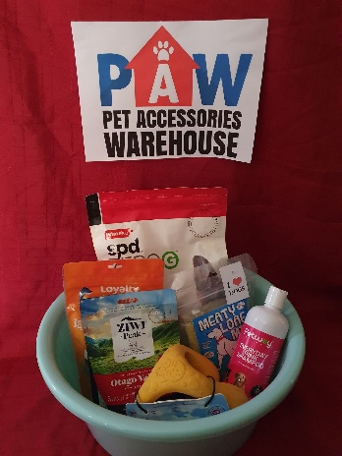
3rd Prize
Sponsored by Pet Accessories Warehouse
1 x Prime 100 Spd Zero 2.2kg Dog Food
1 x Ziwi Peak 140g Dog Food
Total Value $129.00
1 x Wagalot Meaty Loaf Mix
1 x 100g Loyalty Pet Treats
1 x Petway Everyday Pink shampoo
1 x Westpaw Dog Toy

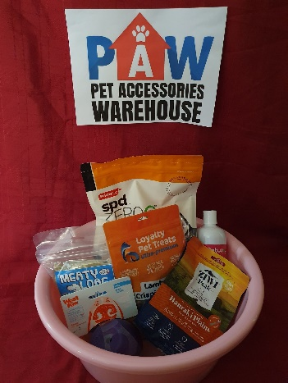
4th Prize
Sponsored by Pet Accessories Warehouse
1 x Prime 100 Spd Zero 2.2kg Dog Food
Total Value $129.00
1 x Ziwi Peak 140g Dog Food
1 x Wagalot Meaty Loaf Mix
1 x 100g Loyalty Pet Treats
1 x Petway Everyday Pink shampoo
1 x Westpaw Dog Toy

